Date: 19 June 2020
Our Ref: TAB/1399
Contact: Mr S Dean
Email: terri.brown@bcpcouncil.gov.uk
Tel: currently working from home

Dear

POOLE QUAY AREA – EXPERIMENTAL ORDER

I enclose for your information a copy of a notice that will in appear in the ‘Public Notice’ Section of the Bournemouth Evening Echo tomorrow, Saturday 20 June 2020 concerning an Experimental Order Proposal to close Poole Quay and the Lower High Street to motorised traffic from 27 June 2020.
I also attach a copy of a letter that has been delivered to residents and businesses in the Quay area.
Relevant notices are on site and details are on the Council’s Web Site

Many thanks

Yours sincerely

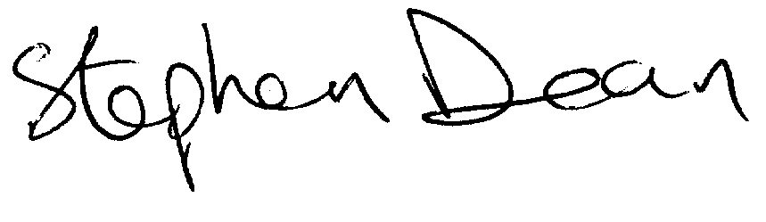
Stephen Dean
Senior Traffic Engineer
Growth and Infrastructure
Currently working from home

